VS Code

-Vs code is a open source free code editor that supports multiple extensions and it is customizable according to user requirements
-To format and make aligning better of your code, right click in code editor canvas->select format document options
-To get information about any line or element or attribute within code, hover on it n u will see short description as a tooltip in canvas.
-It Autocompletes the cmd or suggest commands or elements that you want to type, by clicking ctrl +space
-To Autosave what you are working on in Vs Code ,Go to File Menu ->Enable Auto Save option.
-To identify the error code file and the numbers of error lines, it shows like below
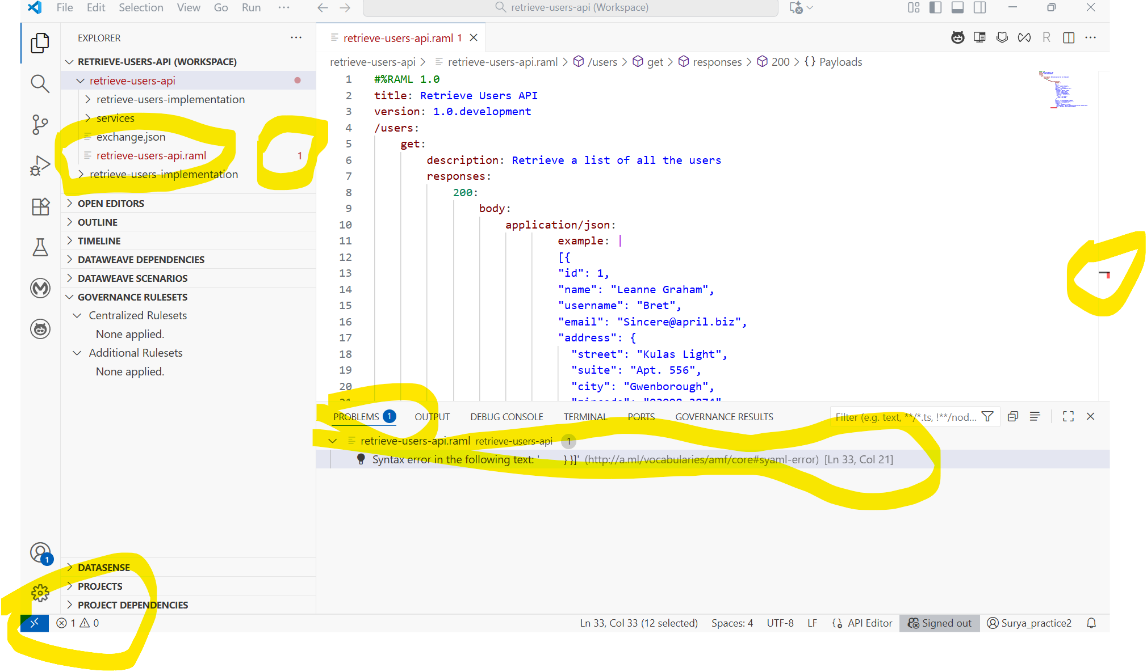
-To enable wordwrap in vscode,go to File->preferences->settings->in search bar settings type wrap->it will open two panel Default settings n user settings ->in default settings select editor.wordwrap which is off by default to make it “on” click on that line in default settings you will see edit(pencil) button-> click on it & select on->after enabling it it will show in user settings panel .->close the user settings window.
-To enable auto-updates of vs code n extensions, go to File->preferences->settings-> in search bar settings type updates->and see if auto update option are checked.

-How to install vs code:
Download Visual Studio Code - Mac, Linux, Windows -> select user installer n start downloading the exe file. Once downloaded n launch the exe filewhich opens wizard select all default values n install vs code

